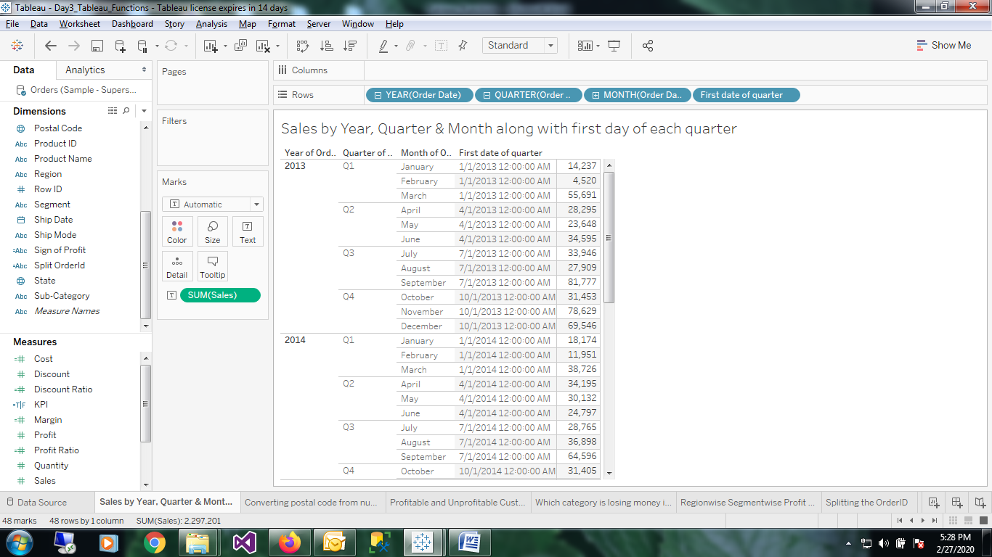

1. Sales by Year,Quarter,Month and First date of the quarter

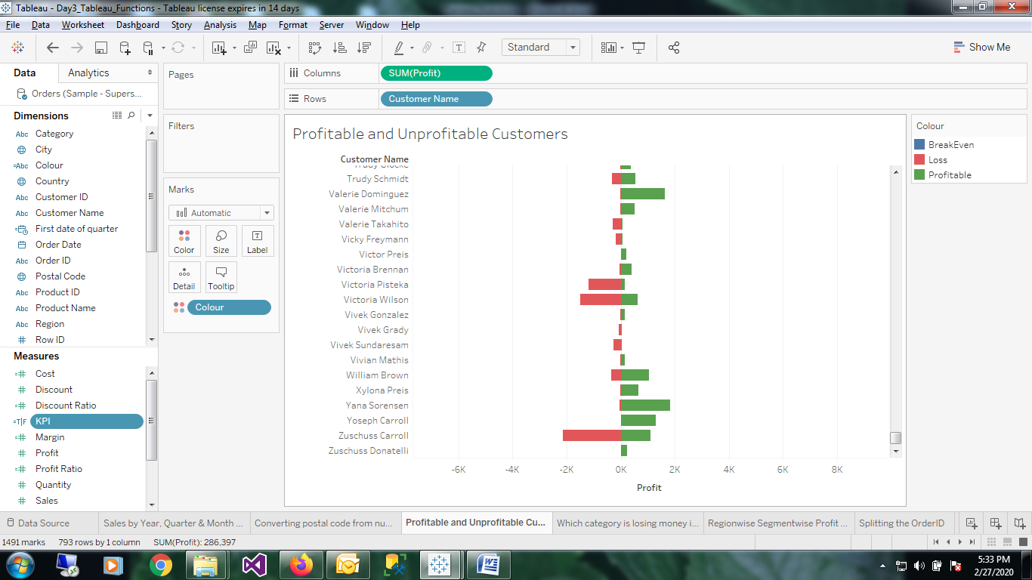

1. Profitable, breakeven and unprofitable customers

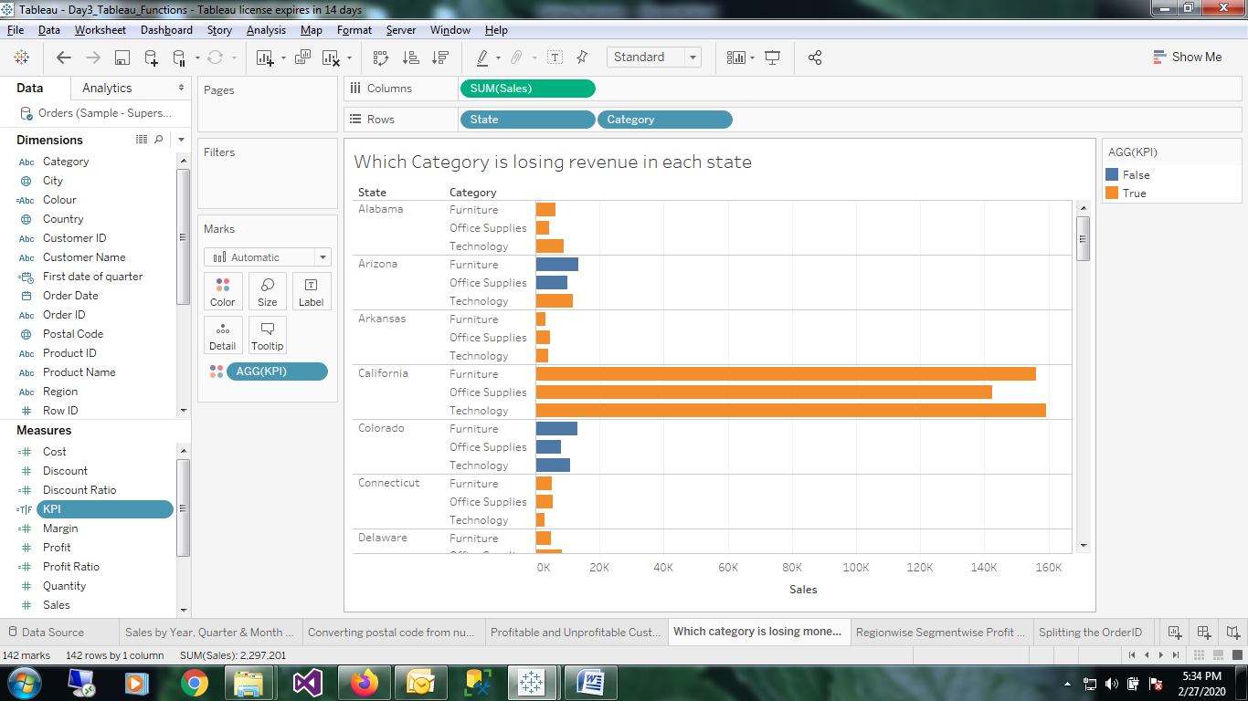

1. Which category is losing revenue in each state

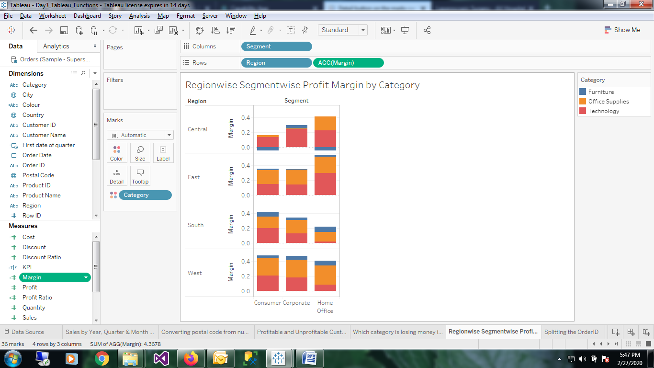

1. Regionwise Segmentwise profit Margin by category

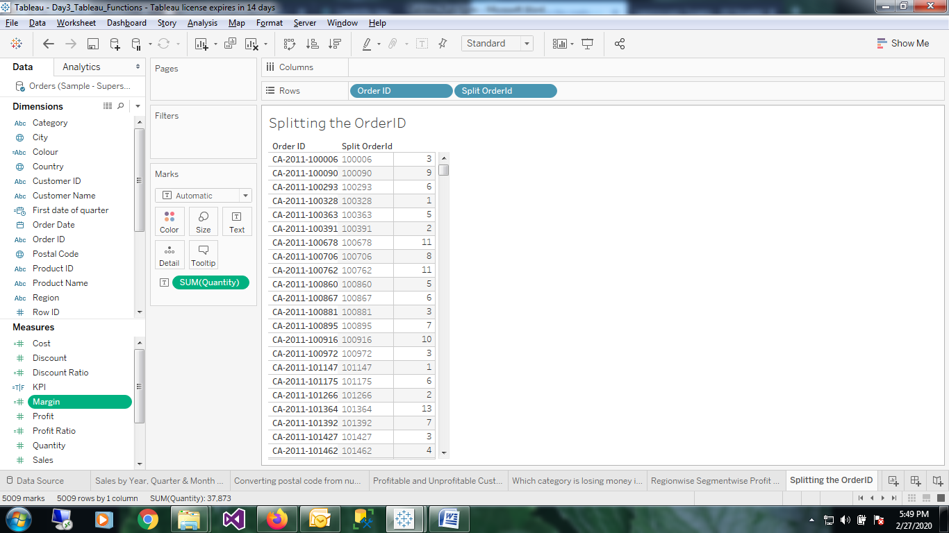

5.Orderwise total Quantity

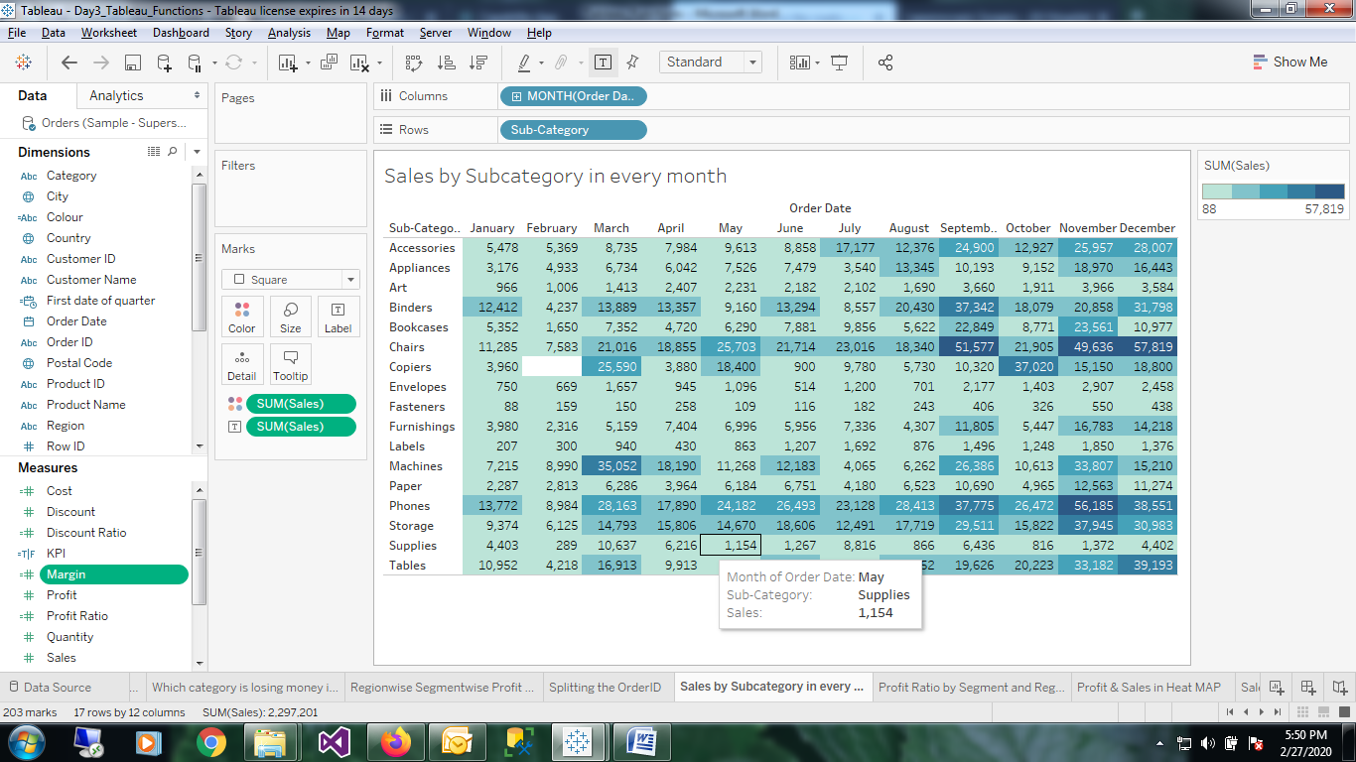

1. Sales by Subcategory in every month

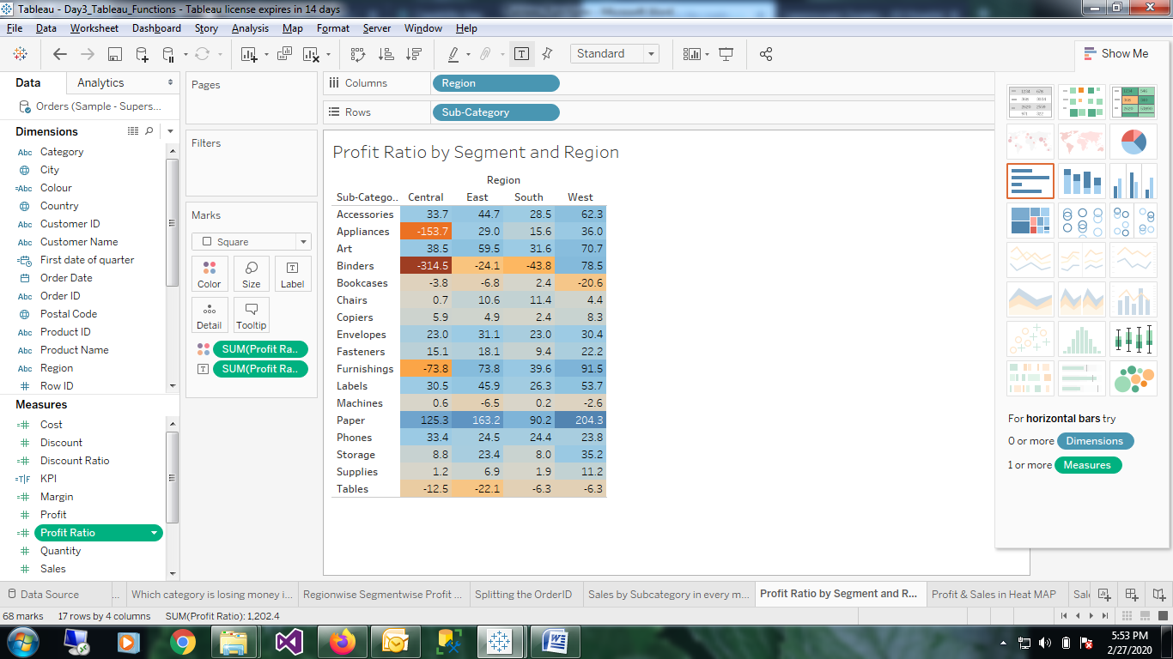

1. Profit Ratio by segment and region

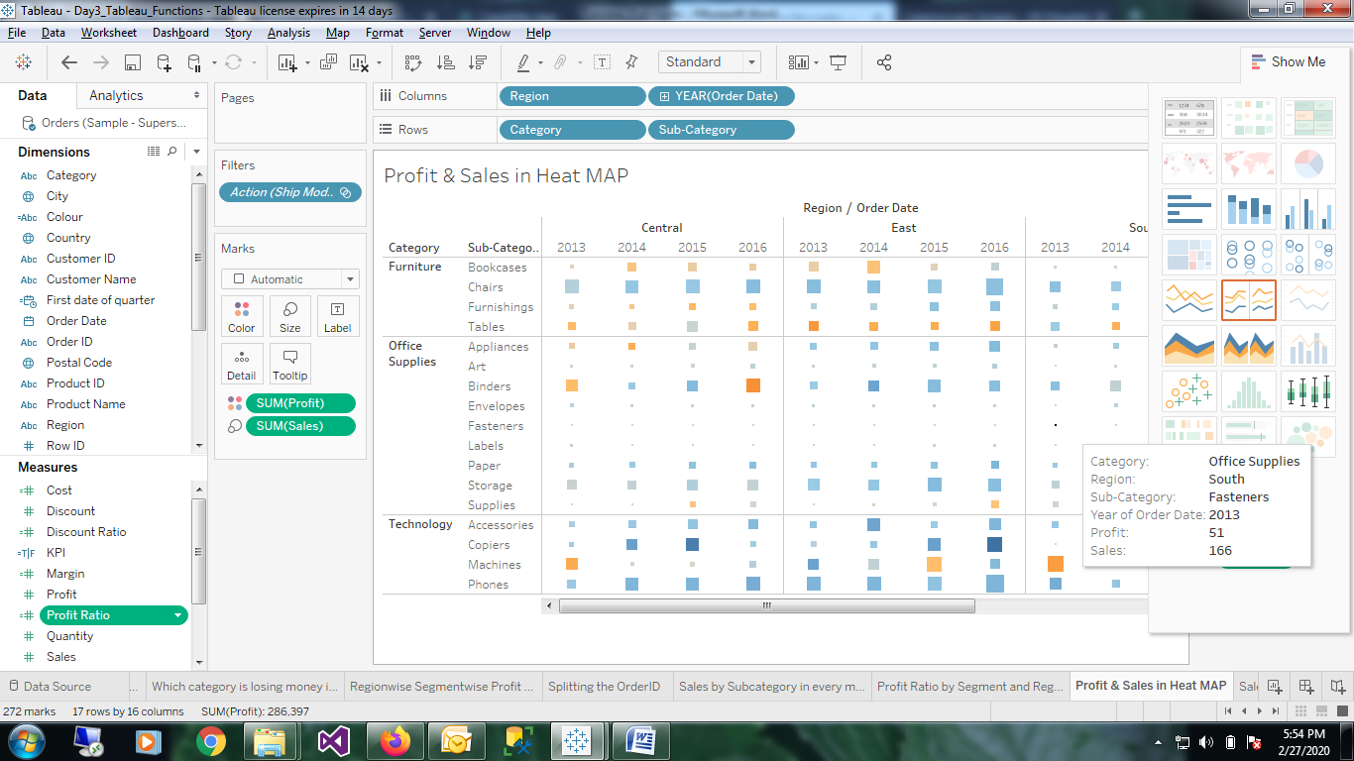

7.Profit and Sales in heat map

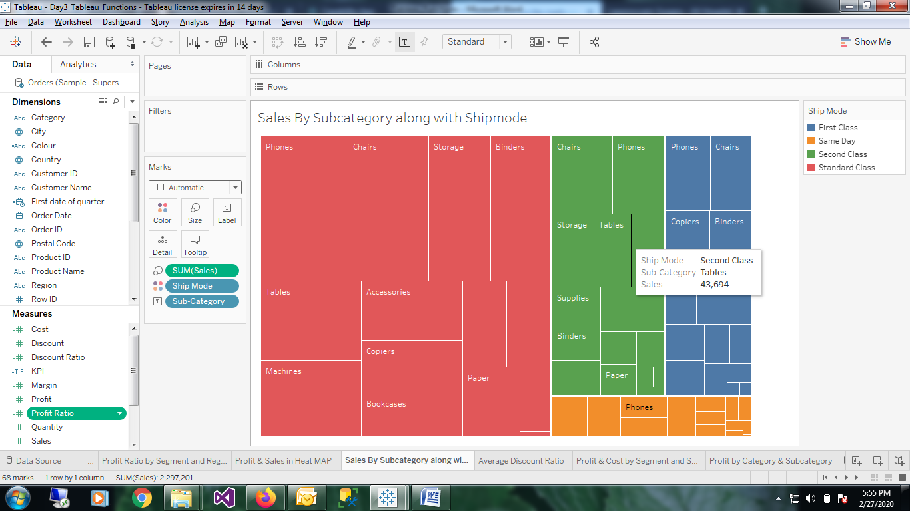

8.Sales by Subcategory along with shipmode in tree maps

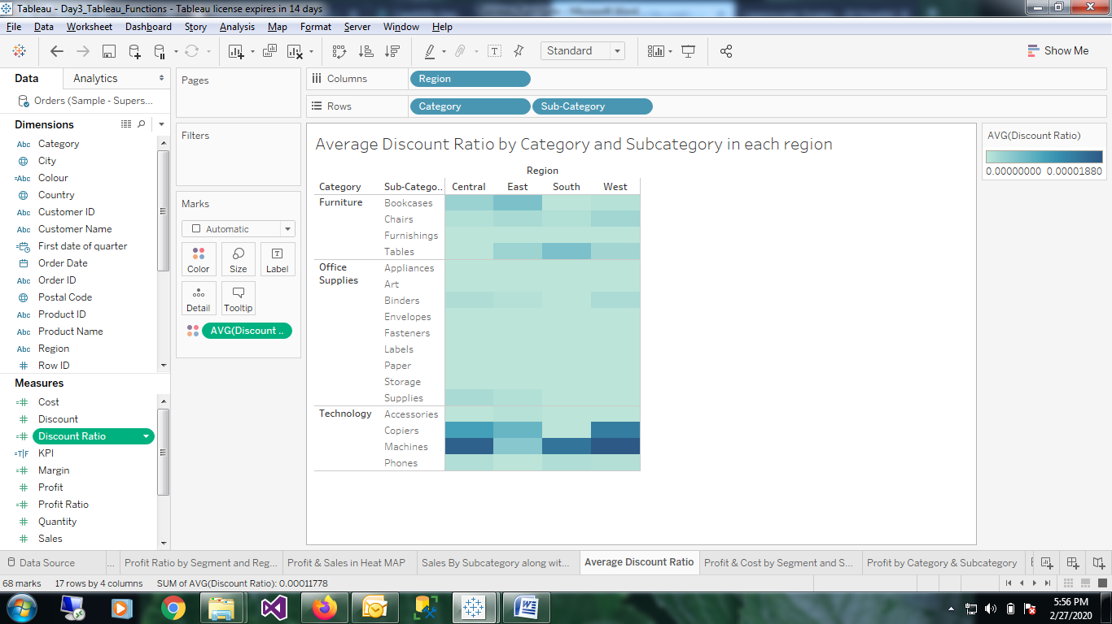

9. Average discount ratio by category and subcategory in each region

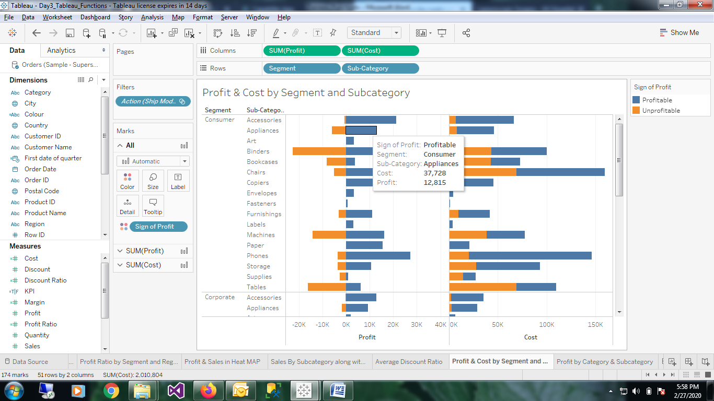

10. Profit and cost by segment and subcategory(with profitable and unprofitable)

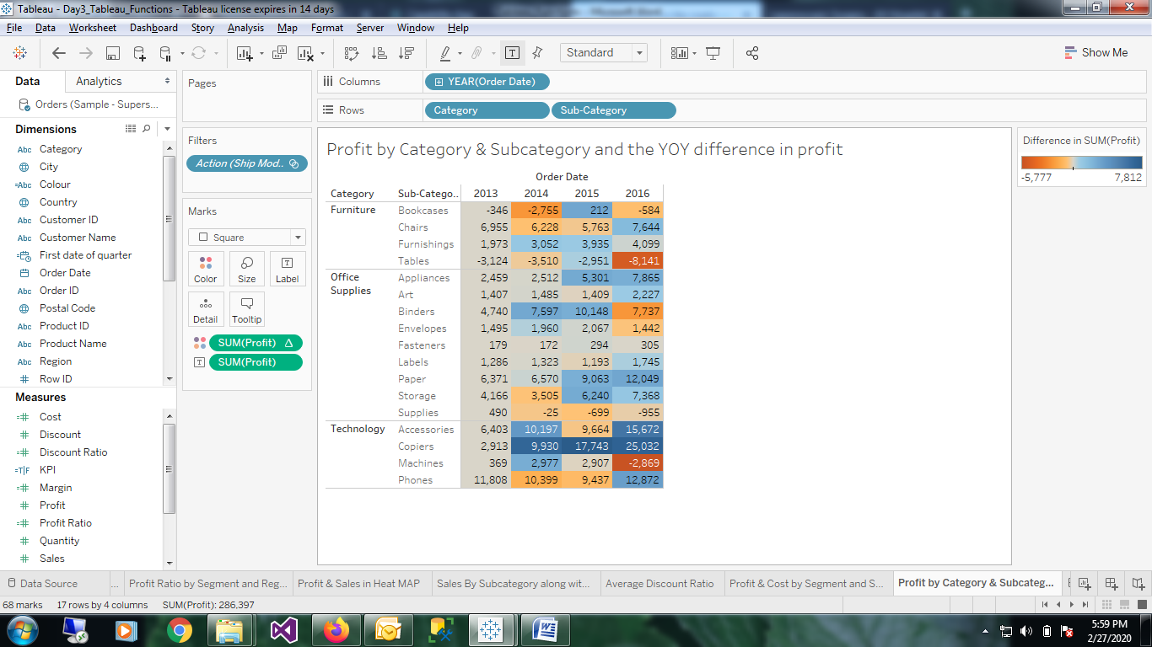

11. Profit by category and subcategory and the YOY difference in profit

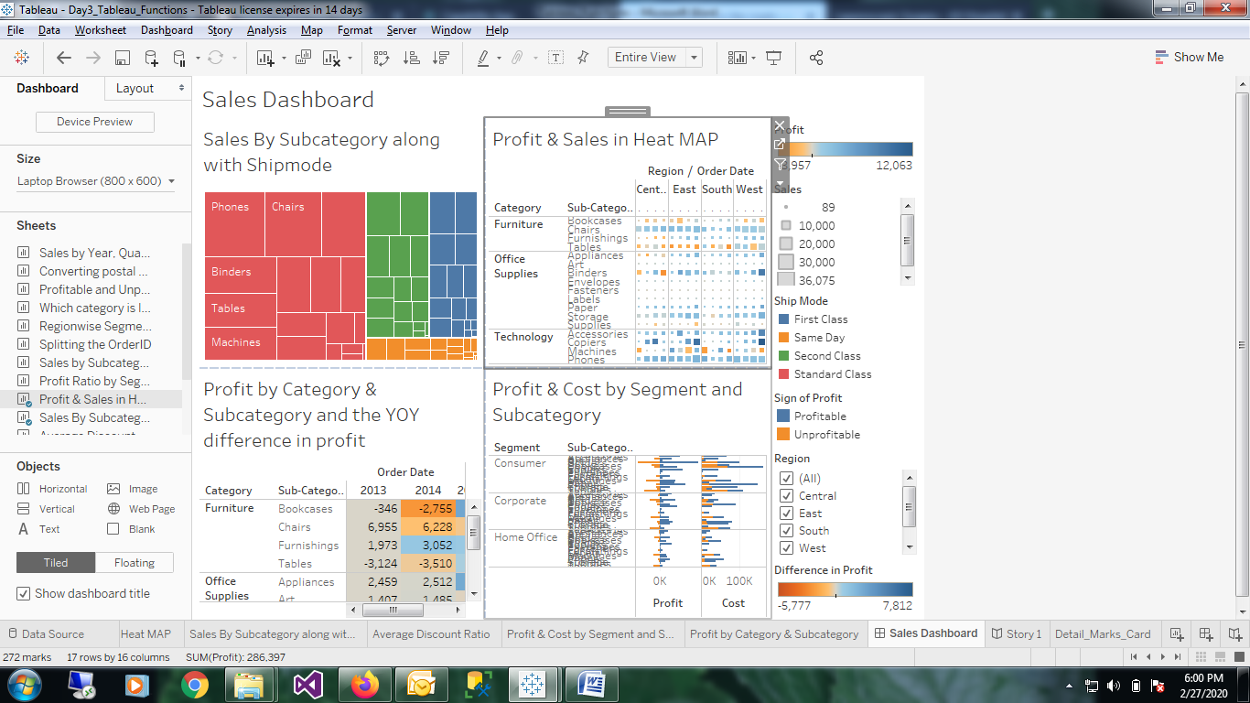

12. Sales Dashboard

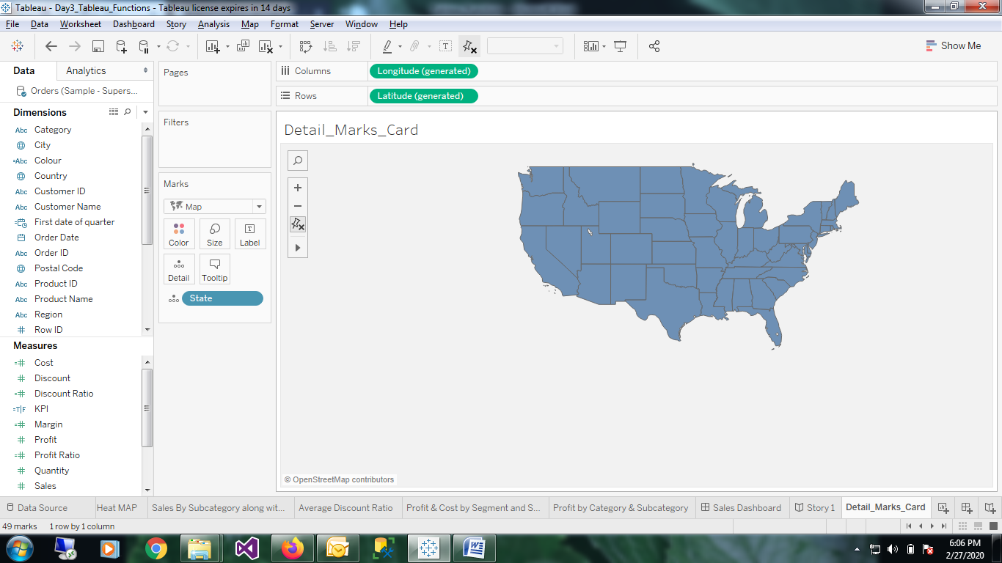

13.Level of detail with Annotations